**Forest Brook Middle School Uniforms 2016-2017**

**Parents please make a note of the following district changes to our dress code:**

* Students are no longer allowed to wear **jeans** with their spirit shirts on Friday. Students will have to wear their uniform khaki pants with their spirit shirts unless they have permission from school administration. **No hooded sweatshirts or jackets are allowed.**
* **School supply lists** will be given to the students by their teachers in class during the first week of school. Please ensure that your students has at least a pencil and paper for the first week.

**6th Grade Uniforms**

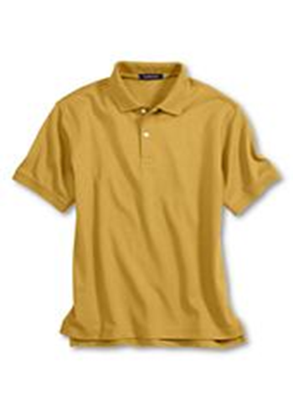

* Gold Polo Shirts - **No logos**
* Khaki or black pants
* Closed toe shoes - **no flip flops, slippers**
* Clear backpacks **only**

**7th Grade Uniforms**

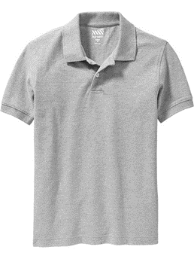

* Grey Polo Shirts - **No logos**
* Khaki or black pants
* ◻ Closed toe shoes - **no flip flops, slippers**
* Clear backpacks **only**

**8th Grade Uniforms**

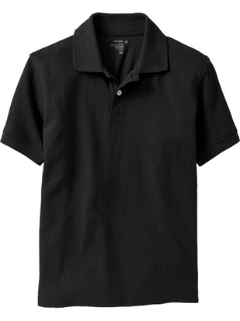

* Black Polo Shirts - **No logos**
* Khaki or black pants
* Closed toe shoes - **no flip flops, slippers**
* Clear backpacks **only**